**Experiment No: 04**

**Experiment name:**

(i): A program to insert an element into a queue and delete an element from a queue.

**Objectives:**

To study, write program and check its result to insert an element into a queue and delete an element from a queue.

**Pseudo code 1:**

#include<stdio.h>

int main()

{

int a[20],top=-1,n,maxsize,value,j,front=-1,rear=-1,count=-1;

printf("Enter value of max size:\n");

scanf("%d",&maxsize);

for(j=0; j<=maxsize; j++)

a[j]=0;

for(;;)

{

printf("\nEnter your option:\n");

scanf("%d",&n);

if(n==1)

{

printf("I am in insertion.\n");

if(count==maxsize)

printf("Overflow\n");

else

{

if(rear==-1)

{

front=0;

rear=0;

}

else if(rear==maxsize)

rear=0;

else

rear=rear+1;

printf("Enter your value:\n");

scanf("%d",&value);

a[rear]=value;

count++;

}

}

else if(n==2)

{

printf("I am in deletion\n");

if(count==-1)

printf("Underflow\n");

else

{

a[front]=0;

count--;

printf("Data successfully deleted.\n");

if(count==-1)

{

front=-1;

rear=-1;

}

else if(front==maxsize)

front=0;

else

front++;

}

}

else if(n==3)

{

printf("I am in display\n");

printf("The Queue values are\n");

for(j=0; j<=maxsize; j++)

printf("%d ",a[j]);

}

else

exit(0);

}

}

**Result 1:**

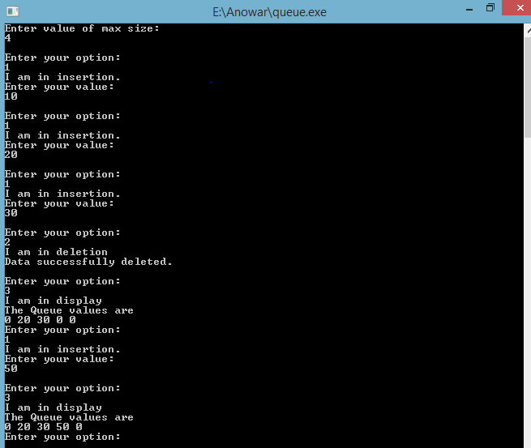

**Discussion:**

There are two types of queue. One is enqueue and another dequeue .Enqueue is insert an element into a queue and dequeue is delete an element from a queue .In the enque, if the count is equal to max size then queue is overflow, Otherwise value is inserted .In the dequeue, if the element is zero then queue is underflow or delete is impossible .Otherwise value is deleted .Firstly, I face many problems to solve this problem. Then our honorable teacher help us to solve this problem .Finally I easily solve this problems.